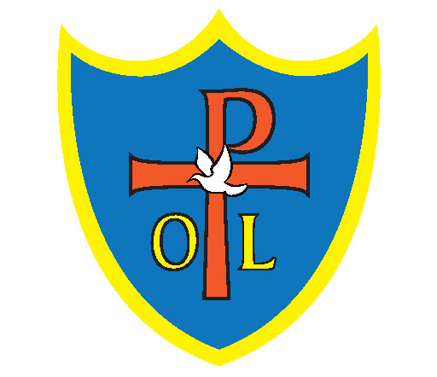Our Lady and St Philomena’s Art & Design Curriculum

|  |  |  |  |
| --- | --- | --- | --- |
| Year 1 | Autumn 1 | Spring 1 | Summer 1 |
|  | **Drawing:**  Make your Mark! | **Painting and mixed media:**  Colour Splash | **Sculpture and 3D:**  Paper Play |
| Year 2 | Autumn 1 | Spring 1 | Summer 1 |
|  | **Drawing**  Tell a Story | **Painting and mixed media:**  Life in Colour | **Sculpture and 3D:**  Clay Houses |
| Year 3 | Autumn 1 | Spring 1 | Summer 1 |
|  | **Drawing**  Growing Artists | **Painting and mixed media:**  Prehistoric Painting | **Sculpture and 3D:**  Abstract Shape and Space |
| Year 4 | Autumn 1 | Spring 1 | Summer 1 |
|  | **Drawing**  Power Prints | **Painting and mixed media:**  Light and Dark | **Sculpture and 3D:**  Mega Materials |
| Year 5 | Autumn 1 | Spring 1 | Summer 1 |
|  | **Drawing**  I Need Space | **Painting and mixed media:**  Portraits | **Sculpture and 3D:**  Interactive Installation |
| Year 6 | Autumn 1 | Spring 1 | Summer 2 |
|  | **Drawing**  Make my Voice Heard | **Painting and mixed media:**  Artist Study | **Sculpture and 3D:**  Making Memories |