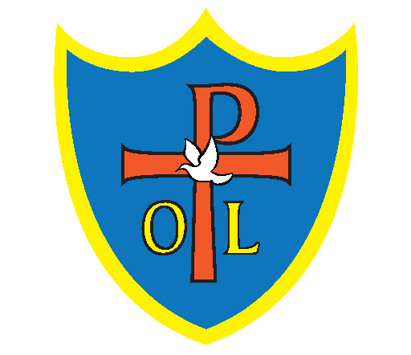Our Lady and St Philomena’s Art & Design Curriculum

|  |  |  |  |
| --- | --- | --- | --- |
| Year 1 | Autumn 1 | Spring 1 | Summer 1 |
| Topic Title  Study of famous artist | **3D**  Can I create my own “another place”?  Antony Gormley – 3D Art | **Collage**  Can I make a collage in the style of Matisse?  Henri Matisse – collage | **Drawing**  Can I draw a likeness of myself?  Pablo Picasso |
| Year 2 | Autumn 1 | Spring 1 | Summer 1 |
| Topic Title  Study of famous artist | **Printing**  Can I print like Frank Stella?  Frank Stella | **Drawing**  Can I reflect how Liverpool has changed since the 1960s?  Peter Carr –Nick Hedges | **Painting**  Can I paint a realistic plant?  Pandora Sellers – comparisons with Claude Monet |
| Year 3 | Autumn 1 | Spring 1 | Summer 1 |
| Topic Title  Study of famous artist | **Digital Collage**  Who would be on my album cover?  Peter Blake – digital collage | **Textiles**  Can I use textiles and fabrics to create an image?  Hannah Höch | **3D**  Can I create a pot like the “Father of British pottery”?  Bernard Leach |
| Year 4 | Autumn 1 | Spring 1 | Summer 1 |
| Topic Title  Study of famous artist | **Drawing**  Can I be as accurate as Leonardo da Vinci?  Leonardo da Vinci | **Digital Media: Photography**  Can I reflect pride in my neighbourhood through art?  Compare Stephen Wiltshire to Bridget Riley  . | **Painting**  Can I paint like Zaha?  Zaha Hadid – Architect |
| Year 5 | Autumn 1 | Spring 1 | Summer 1 |
| Topic Title  Study of famous artist | **3D**  Hats off to Philp Treacy!  Philp Treacy | **Printing**  Can I design a pattern in the style of William Morris?  William Morris | **Collage**  Can I represent the emotional fear as well as the structural damage of war?  Paul Nash |
| Year 6 | Autumn 1 | Spring 1 | Summer 2 |
| Topic Title  Study of famous artist | **Drawing**  Who were the Fauvists?  Marc Chagall | **Painting**  Is LS Lowry’s art bleak and depressing?  LS Lowry | **Photography**  Memories are made of this.  Diane Arbus |