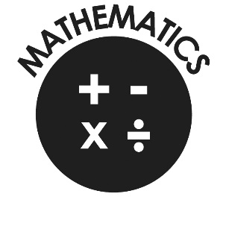

**Mathematics**

Number

* Count reliably to 20.
* Order numbers 1 – 20.
* Say 1 more/1 less to 20.
* Add & subtract two single digit numbers.
* Count on/back to find the answer
* Problem solving including doubling/halving and sharing.

Shape, space and measures

* Use language to compare quantities and objects and problem solve
* Recognise, create and describe patterns and shapes
* Use mathematical language to explore objects around them.

**Our Lady and St Philomena’s Catholic Primary School**



**End of Year Expectations**

**for Reception**

This booklet provides information for parents and carers on the end of year expectations for children in our school. The staff have identified these expectations as being the minimum requirements your child must meet in order to ensure continued progress throughout the following year.

All the objectives will be worked on throughout the year and will be the focus of direct teaching. Any extra support you can provide in helping your children to achieve these is greatly valued.

If you have any queries regarding the content of this booklet or want support in knowing how best to help your child please talk to your child’s teacher.