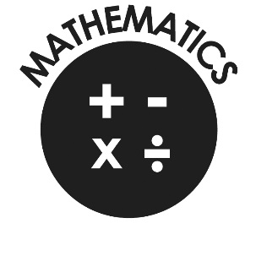

**Mathematics**

* Count to and across 100, forwards & backwards from any number.
* Read and write numbers to 20 in numerals & words.
* Read and write numbers to 100 in numerals.
* Say 1 more/1 less to 100.
* Count in multiples of 2, 5 & 10.
* Use bonds and subtraction facts to 20.
* Add & subtract:
  + 1 digit & 2 digit numbers to 20, including zero.
* Solve one-step multiplication and division using objects, pictorial representation and arrays.
* Recognise half and quarter of object, shape or quantity.
* Sequence events in chronological order.
* Use language of day, week, month and year.
* Tell time to hour & half past.

**Our Lady and St Philomena’s Catholic Primary School**



**End of Year Expectations**

**for Year 1**

This booklet provides information for parents and carers on the end of year expectations for children in our school. The staff have identified these expectations as being the minimum requirements your child must meet in order to ensure continued progress throughout the following year.

All the objectives will be worked on throughout the year and will be the focus of direct teaching. Any extra support you can provide in helping your children to achieve these is greatly valued.

If you have any queries regarding the content of this booklet or want support in knowing how best to help your child please talk to your child’s teacher.