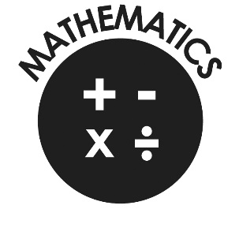

**Mathematics**

* Compare and order numbers up to 100 and use < > =.
* Read and write all numbers to 100 in digits & words.
* Say 10 more/less than any number to 100.
* Count in steps of 2, 3 & 5 from zero and in 10s from any number (forwards and backwards).
* Recall and use multiplication & division facts for 2, 5 & 10 tables.
* Recall and use +/- facts to 20.
* Derive and use related facts to 100.
* Recognise place value of any 2-digit number.
* Add & subtract:
  + 2-digit nos & ones
  + 2-digit nos & tens
  + Two 2-digit nos
  + Three 1-digit nos
* Recognise and use inverse (+/-).
* Calculate and write multiplication & division calculations using multiplication tables.
* Recognise, find, name and write 1/3; 1/4; 2/4; 3/4.
* Write and recognise equivalence of simple fractions.
* Tell time to five minutes, including quarter past/to.

**Our Lady and St Philomena’s Catholic Primary School**



**End of Year Expectations**

**for Year 2**

This booklet provides information for parents and carers on the end of year expectations for children in our school. The staff have identified these expectations as being the minimum requirements your child must meet in order to ensure continued progress throughout the following year.

All the objectives will be worked on throughout the year and will be the focus of direct teaching. Any extra support you can provide in helping your children to achieve these is greatly valued.

If you have any queries regarding the content of this booklet or want support in knowing how best to help your child please talk to your child’s teacher.