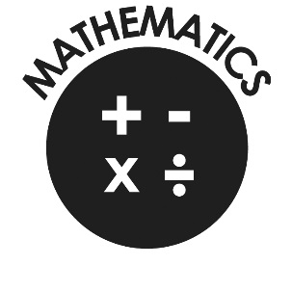

**Mathematics**

* Use negative numbers in context and calculate intervals across zero.
* Compare and order numbers up to 10,000,000.
* Identify common factors, common multiples and prime numbers.
* Round any whole number to a required degree of accuracy.
* Identify the value of each digit to 3 decimal places.
* Use knowledge of order of operations to carry out calculations involving four operations.
* Multiply:
  + 4-digit by 2-digit
* Divide:
  + 4-digit by 2-digit
* Add and subtract fractions with different denominators and mixed numbers.
* Multiply simple pairs of proper fractions, writing the answer in the simplest form.
* Divide proper fractions by whole numbers.
* Calculate % of whole number.

**Our Lady & St Philomena’s Catholic Primary School**



**End of Year Expectations**

**for Year 6**

This booklet provides information for parents and carers on the end of year expectations for children in our school. The staff have identified these expectations as being the minimum requirements your child must meet in order to ensure continued progress throughout the following year.

All the objectives will be worked on throughout the year and will be the focus of direct teaching. Any extra support you can provide in helping your children to achieve these is greatly valued.

If you have any queries regarding the content of this booklet or want support in knowing how best to help your child please talk to your child’s teacher.