**Liverpool Schools Football Association**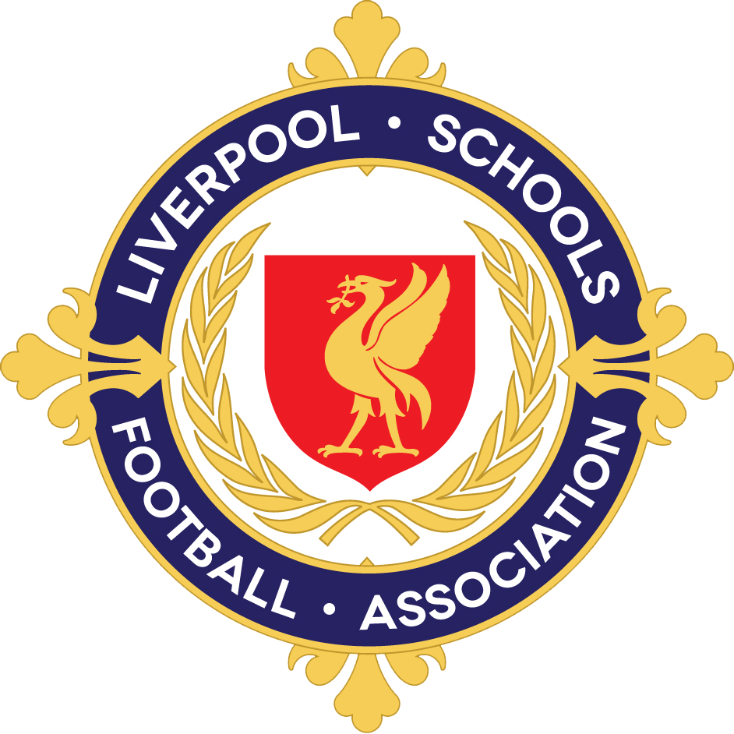

Serving the schools and children of Liverpool since1887

**Liverpool Primary and U12 Teams Trials for 2022/23**

You can now nominate your son or daughter for our Primary teams for season 2022/23.

To do this:

* Go to our website <https://www.liverpoolschoolsfa.org.uk>
* Go to About Us/Nomination Forms for 2022/23
* Select the correct nomination form for your son or daughter
* Complete and submit the form

You will receive en email receipt, which you can use to edit the form if necessary.

**Ensure you have the correct year group form**

* Under 10 Boys team - current Y4, Y5 in September 2022
* Under 11 Boys team - current Y5 Y6 in September 2022
* Under 12 Boys team - current Y6, Y7 in September 2022
* Under 11 Girls team - current Y5, Y6 in September 2022
* Under 12 Girls team - current Y6, Y7 in September 2022

Girls at RTCs can now play for the Liverpool Schoolgirls team.

**Eligible Schools**

* Your son or daughter **must**  go to a school which is part of Liverpool Local Authority to trial or play for any of our teams. There is a list of the schools eligible for Liverpool Schoolboys or girls under 'about us' on our website.
* Please check the school they will be in in September is on this list before you nominate.

Team managers will be in touch with you directly regarding dates, times and venues of trials.

We look forward to meeting you at the trials, and good luck!

If you have any queries please email admin@iverpoolschoolsfa.org.uk