Read a story, sing a song or play a game in Spanish  (free 3 month membership)  Babelzone  Interactive games in French and Spanish. Use the code LCF2020sch  https://www.lcfclubs.com/babelzoneNEW/   | Sing and dance in Spanish.  https://www.youtube.com/watch?v=oNU67X3dGHI  https://www.youtube.com/watch?v=l7fQt77Y7N4  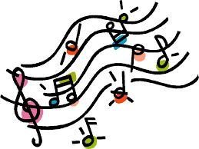 | Learn some new Spanish words  https://www.education.vic.gov.au/languagesonline/spanish/spanish.htm  
Practise counting 1 - 20  https://www.youtube.com/watch?v=-UN6PtHxWLY  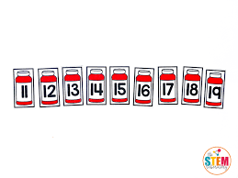 | Make a decorated bookmark with Spanish greetings on it.  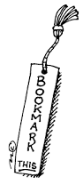 | Find out about a country where Spanish is spoken and make a poster to tell your friends about it.  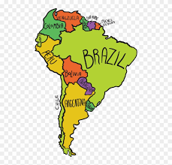

Make some Spanish pancakes  https://spanishsabores.com/2016/01/19/frisuelos-recipe-spanish-style-crepes/  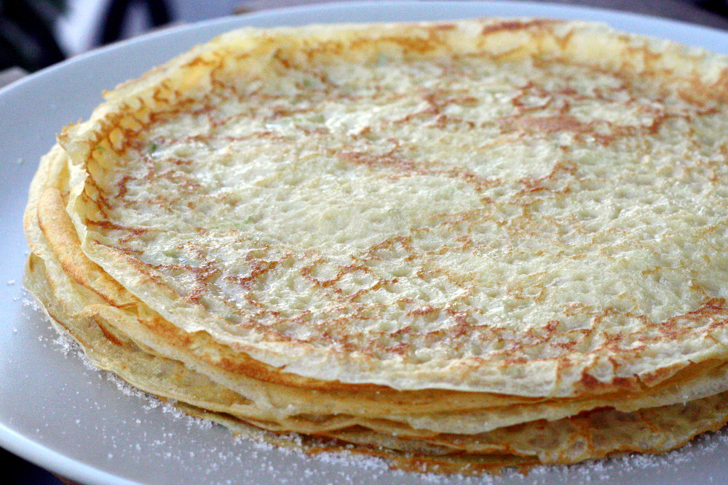 | Find out about the festival in Spain called La Tomatina.  What do people do?  https://www.lcfclubs.com/babelzoneNEW/   | Enjoy a Spanish story  https://www.thespanishexperiment.com/stories?fbclid=IwAR0dvE1xJ-bzmJXjQKpfhRAQu02fWIGHsc9Kk4JfzxiJD2qpjALBV6FR6BA  