Learn New Vocabulary  Complete the short High Five Spanish videos to learn vocabulary from some new topics.  https://radiolingua.com/learnathome/#primaryspanish  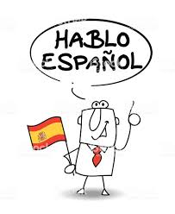 |  | Language Log  Keep a language log of all new words learnt whilst you are away from school. You can organise this either by topic or in alphabetical order.  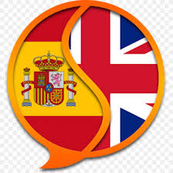 | Appreciate Art  Take a virtual tour of the Picasso museum in Barcelona.  http://courtyard.museupicassobcn.org/virtual-tour  Choose a piece of artwork that you particularly like and write a summary of what you learnt about it.  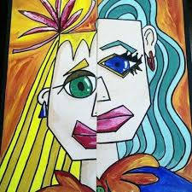
Rhyme time  Copy out and illustrate this traditional rhyme. Make up actions can use when you repeat it.  Learn about other Spanish rhymes  www.mamalisa.com |  | Quiz Time  Research and set 10 questions in English for someone else to answer about Spain.   | Visual Dictionary  Create a visual dictionary by taking photos of different rooms in the house or items of furniture and finding the Spanish word using  https://www.collinsdictionary.com/dictionary/english-spanish  
Son las 12, son las 12  Vamos ya, vamos ya  Vamos a casita  Vamos a casita  Con mama y con papa  Son las 12, son las 12  Vamos ya, vamos ya  Toca la campana  Toca la campana  Ding, dong, dan  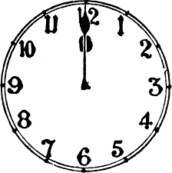 | It's 12 o'clock, it's 12 o'clock,  Let's go now, let's go now!  Let us go to our house,  Let us go to our house  with mum and with dad.  It's 12 o'clock, it's 12 o'clock,  Let's go now, let's go now!  Go and ring the church bell  Go and ring the church bell,  Ding dang dong  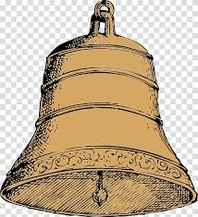
You’ve Got Mail  Write a postcard in Spanish. Say hello, what your name is, how old you are, something that you like, and goodbye. Maybe you can send it to a friend!  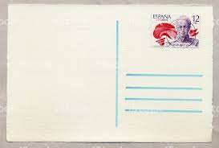 |  | ¡Trabalenguas!  Have a go at these tongue twisters from Latin America!  https://www.youtube.com/watch?v=JHuDd4PwCa4  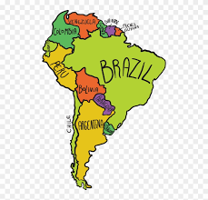 | Play Spanish vocabulary games  Rockalingua  Free interactive games in Spanish.  https://rockalingua.com/  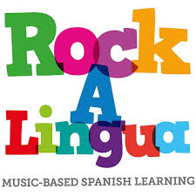
Famous Spanish People  Create a power point presentation about famous Spanish people. They could be artists, authors, sports people, musicians or historical figures.  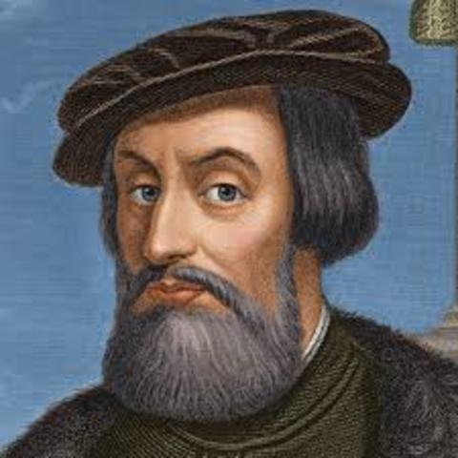 |  | El mundo hispánico  Make a line of paper dolls from a concertina of paper and decorate each one in the flag colours of a different Spanish-speaking country.  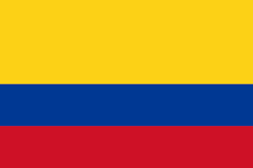 | Spanish recipe book.  Research and create an illustrated book of traditional Spanish recipes.  