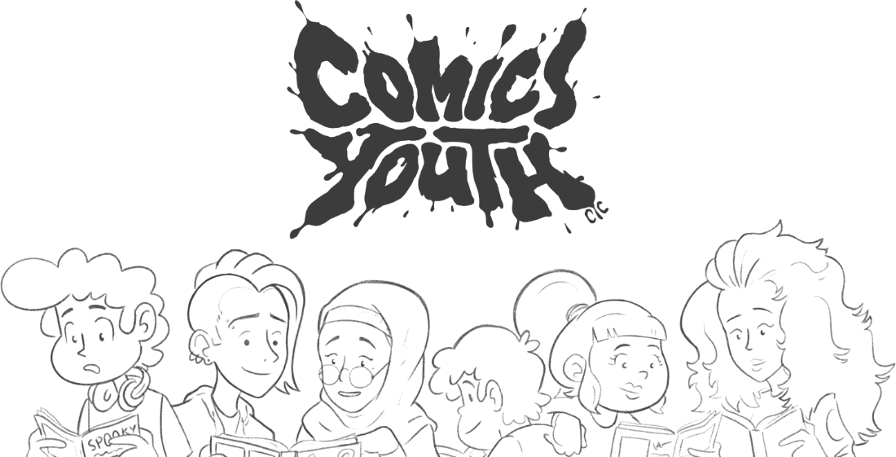

By youth, for youth: Creativity that moves beyond the margins
Comics Youth, Suite 303, Tempest Building, Tithebarn Street, L2 2DT
comicsyouth.co.uk//@ComicsYouth

Comics Youth Launch Second Round of the Stay Safe Club: Free Care and Wellbeing Packs to Young People Across the Liverpool City Region

Liverpool based youth organisation Comics Youth are excited to announce the re-launch of their popular Stay Safe Club initiative – a project designed to help support young people aged 8 – 25 through the intense challenges of living in lockdown during the global Covid-19 pandemic.
In August, Comics Youth sent out over 1,000 care packages to young people across the Liverpool City Region during the initial round of the Stay Safe Club, when the organisation was overwhelmed with requests to receive one.

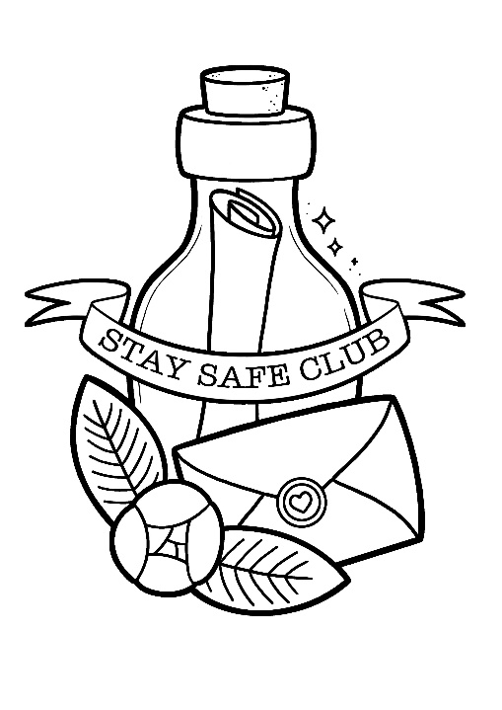
The intense demand for the free care packages highlighted that there remains an obvious need for more kindness to be shared during this difficult time, and that a second Stay Safe Club – to be delivered during the festive season – is essential for continuing to remind young people that no matter what challenges they currently face, they aren’t alone.

Each Stay Safe Club package is free and packed full of nurturing, mood-boosting treats lovingly curated by the vibrant young community at the heart of Comics Youth. It includes an exclusive Stay Safe Club bullet journal, modelling clay, stickers, a folding friend, riso prints, festive cards, and a Comics Youth beanie hat – to keep heads feeling warm but looking cool throughout Winter!

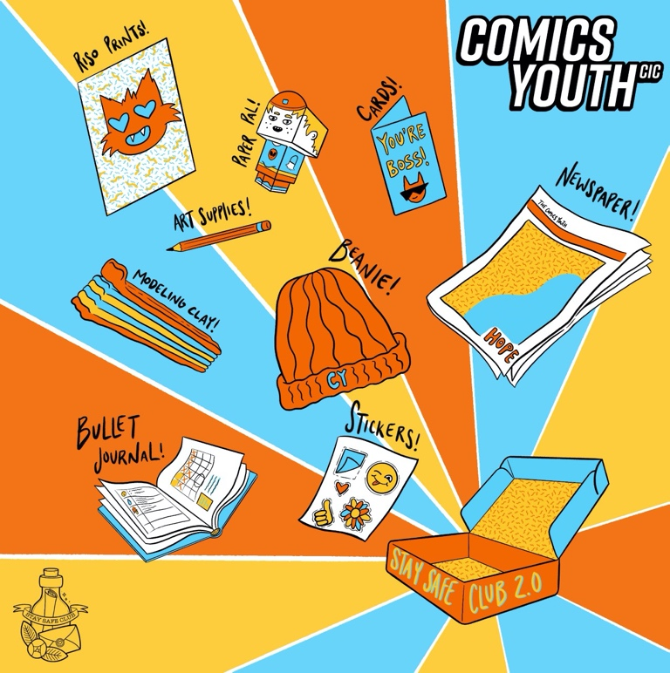
With 2020 (finally) coming to an end, and a new year beginning, Comics Youth want to help spread some hope and encourage young people to remain optimistic and resilient in the face of adversity.

In trying to help inspire feelings of optimism and resilience with the Stay Safe Club, each package will also contain the first issue of Beyond the Margins – the highly acclaimed Comics Youth newspaper project designed and developed by young people across Liverpool.

Featuring over 50 colour pages of writing and artwork created by young people before and during lockdown on the theme of Hope, the newspaper has been consciously put together with the intention to inspire joy, courage, and reassurance in everyone who reads it.

The Stay Safe Club was set up earlier this year as an extension to the Safe Spaces project – a digital programme helping marginalised young people across the Liverpool City Region to create and maintain environments that are nurturing and supportive to their identities and wellbeing online and IRL. The Safe Spaces project is made possible thanks to funding from The Co-Op Foundation.

People can apply to receive a Stay Safe Club box via our website https://comicsyouth.co.uk/staysafeclub before the closing date of Friday 11th December.

About Comics Youth

Comics Youth was founded in 2015 and is a creative community organisation led by young people, for young people. Our aim is to empower youth across the Liverpool City Region to flourish from the margins of society: Harnessing their own narratives, finding confidence within an inclusive community, and developing the resilience to succeed on their own path.

To find out more about Comics Youth please visit www.comicsyouth.co.uk |Facebook | Twitter | Instagram |

For further enquiries please contact:
Amy Roberts, Marketing and Communications Officer
amy@comicsyouth.co.uk

