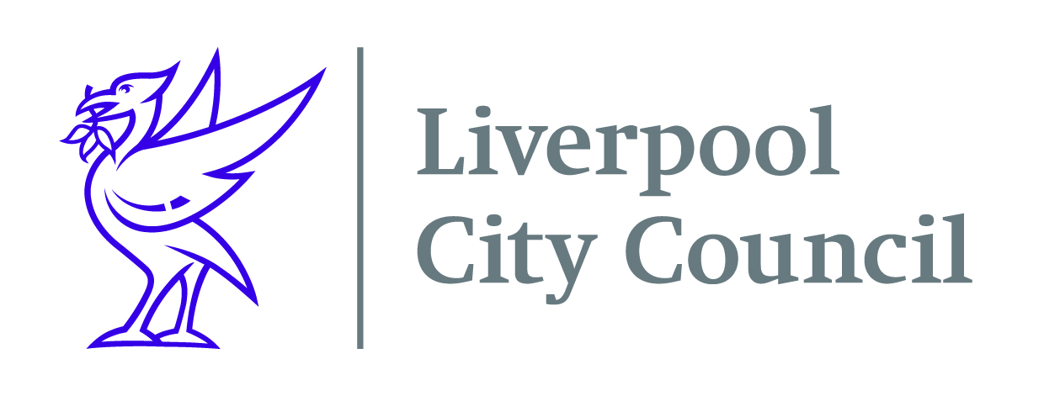

Date: 9th February 2022

Dear Parent or Guardian
The Fab Feb Half term programme starts on the 21st February and is packed with a wide variety of activities for children and young people aged 5-16 years old.
There are hundreds of activities throughout the winter break including specific provision available for children with SEND or additional needs, at no cost to you. There’s a great range of activities across the city including boxing, trampolining, football camps, drumming, dance, roller skating, ice skating, cooking, films, bowling, arts and crafts, drama, trips out, radio show and music production and much more! Every day there will be food available for every child that attends.
To find out where your nearest scheme is please click on this link – https://www.merseyplay.com/fab-feb-half-term-activities/ or visit www.Merseyplay.com and click on the Fab Feb half term link.
When you have chosen an activity, you will need to contact that organisation to book a place. If your child has any additional needs or dietary requirements then please discuss this with the organisation when you book.
Liverpool City Council is working with the local schools, voluntary and community organisations, and childcare providers to provide the Fab Feb half term programme.
In order to help the city recover from the Coronavirus pandemic Liverpool City Council has pledged to help families Get Connected to the internet. The Get Connected pledge will see families, eligible for benefits related free school meals, which currently do not have a broadband connection, receive a fully funded wireless connection and equipment for one year.
To check the full eligibility criteria and to apply, go to liverpool.gov.uk/getconnected or call the Get Connected team on 0151 233 3073.

Regards
Sally Dobbing
Sally Dobbing - HAF Project Manager

