**New Family Learning and Engagement Courses**

***The Adult Learning Service can bring specially designed, short courses to your school, children’s centre or community centre.***

*Our courses support families, for personal development and for health and wellbeing.*

*All courses have progression routes that can lead on towards gaining an accredited qualification.*

**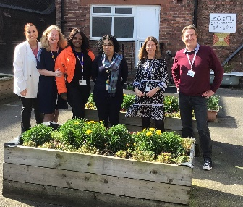*---------------------------------------------------------------------------------------------------------------------------------***

Dear School, Children’s Centre, or Community Organisation

My name is Michele Ross and I wanted to introduce myself and the team here at Liverpool City Council’s Adult Learning Centre. I hope this letter finds you all well and I’m writing to you to give you an update about the activities, services and support that is available for you to access. We can bring family learning courses and activities directly to your venue or we can deliver them at one of our centres.

**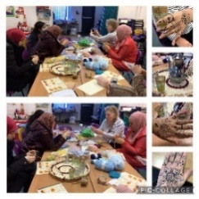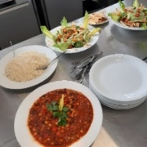**We have **ESOL** relatedclasses which supports the development of English which could help parents support their child with homework and provide better skills to access work. For example, our English conversation classes. These courses also include trips and visits to local facilities such as libraries and may help you access a range of services within your community.

**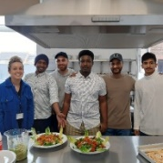**Pictures on the left are of the recent parent classes we held at Holy Family School.

**Recent activities for parents with one of our Food tutors, Sophie** (pictured right) **…**

* **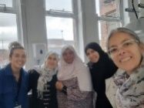**Cooking healthy recipes from different cultures, using fresh and easily available ingredients. Understanding how to read recipes in English and expand cooking confidence
* Developing wellbeing through a range of craft activities and gardening – including painting, colour therapy session, gardening and planting
* **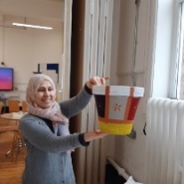**Developing a range of skills including maths, IT, and reading & writing English – through weighing ingredients, measuring, smartboard internet research and recipe writing. This can help you with your child’s homework
* Exploring next steps and referring learners to our on- site Employment team for career or volunteer advice

**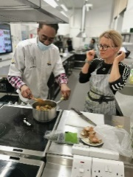**

**Not to worry if your venue doesn’t have a kitchen or a classroom as the good news is…** at Granby and Newsham we have kitchens and classrooms you can use. We offer a wide range of courses that celebrate our cultures through world foods. This is great for meeting up, cooking, eating, and learning together, and to help you to find out more about the food that we eat, including nutrition and health benefits.

Also, our brilliant **textiles** and **garment** classes run every week with **tutor** **Mareen** and include sewing, repairs, garment making etc. Lots of people who take the class use this to make their children’s clothes and some are now even offering sewing services locally around the Lodge Lane area.



Learner comments:

*“I really enjoyed yoga; I always feel relaxed after the yoga session”*

*“Yoga helps me to feel relaxed and improves my wellbeing in general”*

*“I enjoyed all the session. It really helps me to feel better and relax”*

*“Thank you, Jayne, for being a wonderful teacher throughout the sessions”*

We also offer **yoga** classes and wellbeing courses with our tutor **Jayne**. These are good to improve mental health, wellbeing, and relaxation. Here you will learn the techniques that can be used in your everyday life. All you need to bring is a yoga mat, water and wear comfortable clothing.

**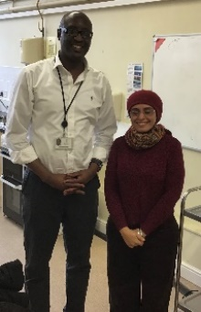Ways to Work…**

**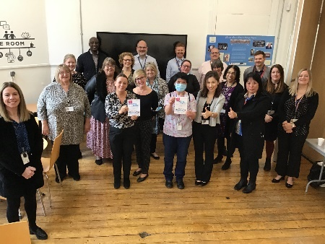Richard** (pictured right) and our fantastic in-house **employment support advisors** (pictured left), who work from the Centres can help people to find employment or further training towards better employment. They can help you with job searches, interview skills and show you how to create that standout job CV.

We have centres city-wide, based at Granby, Newsham Drive, Park Road and Norris Green. Our courses and services are all available for you to access and you are more than welcome to pop along to one of the centres to find out more, or view our range of courses and services online:

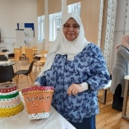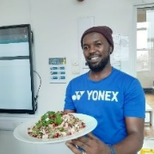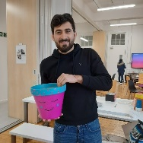**Visit:** Liverpool.gov.uk/learninginliverpool

**E:** Adult.Education.Queries@liverpool.gov.uk

**Telephone:** 0151 233 3026

**We want to give you a very big warm welcome…**

Our centres are at the very heart of your community, and we want to make sure that we get things right for you and provide you with the types of services, courses and activities that meet your needs.

**People often ask…** **do I need to pay for a course?**

Many of our courses are **FREE** when in receipt of certain benefits\*. Family Learning, Maths, English and some IT courses are free.

The minimum numbers of learners required is 10 people and the maximum number is 12.

**(Evidence of benefit will be required by the course tutor upon enrolment).**

**\*Job Seekers Allowance, \*Employment Support Allowance (Work Related Activity Group Only) \*Universal Credit, Income Support, Housing Benefit, Council Tax Benefit, Working Tax Credit, ESA (Support Group). If you are earning less than £19,500 courses are free.**

**Many thanks for reading. We look forward to working with you and providing family learning courses at your venue, organisation or at one of our centres.**

**Michele Ross, Pathways Manager, Adult Learning at Liverpool City Council.**

**Tell us...**

We would love to hear more about what courses you would like to see running at your venue.

|  |
| --- |
| **What courses or activities would you be interested in?**  **Please tick the courses that would interest you**:    Maths: Getting Started with Family Maths/Helping your Child with their Homework  English: Getting Started with Family Literacy//Helping your Child with their Homework  English: Conversation Club – Improve Your Spoken Language  English: Help Your Children Write Creatively at School  IT: Introduction to Computers for Beginners  IT: Essential Digital Skills Entry 3 & Level 1  Cookery: Family Cookery – Variety of courses on request eg Low Cost Meals  Cookery: Authentic Chinese Cookery  Cookery: Cook, Meet and Eat  Cookery: Mediterranean dishes  Cookery: Men’s Cooking Club  Crafts: Seasonal Arts and Crafts  Crafts: Mixed Media Arts/Crafts  Crafts: Hand Sewing  Crafts: Embroidery Basics  Crafts: Make Your Own Cushions  Crafts: Muslim Women’s Sewing Club  Wellbeing: Introduction to Laughter Yoga and Relaxation Techniques  Wellbeing: Introduction Mindfulness  Wellbeing: 5 Ways to Wellbeing  Wellbeing: Culture of Kindness  Wellbeing: Resilience and Relaxation  Wellbeing: Mental Health First Aid  Wellbeing: Colour Therapy  Languages: Intro to Spanish – Help your Children with their Language classes  Languages: Intro to Arabic – Speaking and Listening or Reading and Writing  Languages: Intro to Interpreting  Photography: Family Photography Take Great Photos of your Family  Photography: Photography for Beginners  Employability: Paediatric First Aid  Employability: Family First Aid L2 – One Day Course  Employability: Health and Safety L2 – One Day Course  Employability: Food Hygiene - L2 – One Day Course  Employability: Help looking for Work, CV’s, Job Interviews  Environment: Horticulture: Grow Together – Poly Tunnel  Design your own course to suit your organisation:  **Please provide your details so we can contact you about courses**:  Pen with solid fillName:  Receiver with solid fill Phone number:  Envelope with solid fill Email:  Open envelope with solid fill Address: Post Code: |
|  |

Please return this form via email to:

**E:** michele.ross@liverpool.gov.uk **or E:** [julia.hooks@liverpool.gov.uk](mailto:julia.hooks@liverpool.gov.uk)

C:\Users\Crosbiet\AppData\Local\Microsoft\Windows\INetCache\Content.Outlook\6CCFR0CM\LogoESF_Col_Landscape.png**Ways to Work** is a regional scheme funded by the European Social Fund and Youth Employment Initiative.

C:\Users\Crosbiet.CITY.004\AppData\Local\Microsoft\Windows\Temporary Internet Files\Content.Outlook\WGSX7DCF\ALS logo strip (002).jpg