FREE Bite-size training for parents & carers

View this email in your browser



Parent and carer training opportunities - please share with your parent and carers


Youth Connect 5 in Transit focuses on parents with children and young people transitioning from year 6 (primary) to year 7 (secondary).
This is a pilot course and the team will be looking for feedback which will shape future training.

Book here


The RAISE Team at Merseyside Youth Association has developed a range of bite-size sessions designed for parents and carers.
The one-hour sessions are delivered on Zoom.

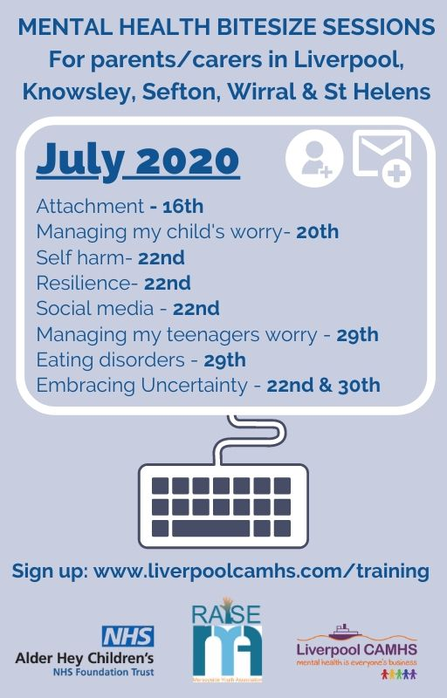

Attachment, covering:
- What attachment is, giving a brief overview of attachment, along with introducing the importance of attachment for early brain development and infant mental health and wellbeing.
- The barriers to developing healthy attachment and what the impact of this can be on an infants development.
- Strategies and tips on how to nurture attachment in the early years and beyond, emphasising the need to support attachment across all ages.
Book here

Managing my child's worry, covering:
- What worry is, how it differs from anxiety and why as parents we need to support our children to worry and find effective ways to control worry.
- Introducing the concept of worry time along, the importance of learning your children about the anxiety response.
- Exploring ways to communicate with your child about worry and the views of young people; things they wished their parents had asked them when they were worried.
- Explore self-help strategies to support worry and anxiety.
Book here

Self-harm, covering:
- Why young people may self-harm, and an emphasis made on self-harm is a behaviour, not a mental health illness.
- Positive strategies for adults to use with children and young people along with helpful apps, tips and resources on how you can promote aspects of resilience from this.
Book here

Resilience, covering:
- What are the key aspects of resilience, why it is important to support children and young people in building resilience and strategies on how to do this.
- Insight into the current resources that are available for you to use and what MYA are doing to promote resilience during the lockdown.
Book here

Social media, covering:
- Strategies on how to promote safety to children and young people when using these apps.
- How technology and social media can be good for their mental health and how we can promote aspects of resilience from this.
Book here

Managing my teenager's worry, covering:
What teenagers are worrying about when to be concerned about your teenager, how to help with teenage issues and worries
Book here

Eating disorders, covering:
- Isolation with no routine being a potential trigger.
- The causes of eating disorders, signs and symptoms to look out for, the different types of eating disorders and the negative influence social media can have on a young person.
- Insight into the current resources that are available for you to use and tips if you are worried about a young person.
Book here

Embracing uncertainty, covering:
- What we mean when we say, ‘be present’ and the benefits of being present.
- Techniques to help you work on being more present and explore concepts such as mindfulness and grounding techniques.
- Making small changes to your routine to support your mental health and wellbeing and the benefits of reducing worry about the past and the future.
Book here


We are looking at developing training on mental health for the Early Years sector and want to establish the level of knowledge and understanding amongst professionals working across this phase.
If you work in Early Years, please take part in this survey to help us identify the training needs that will inform a training programme useful and relevant to your day to day practice.

Take part in the survey

Bite-size training for professionals

These sessions cover a range of mental health issues which impact on children, young people and their families.
The sessions will last between 30 - 60 minutes and will be delivered via the video-calling tool, Zoom, to groups of people at various times of the day and evening.

View the full bite-size training calendar here

Children and young people, parents and carers in crisis can call the
Alder Hey CAMHS crisis care line 24 hours a day, seven days a week on 0151 293 3577
They should only present to Accident Emergency Department if they need medical treatment or are struggling to keep themselves safe in the immediate moment.









 | Share

 | Tweet

 | Forward

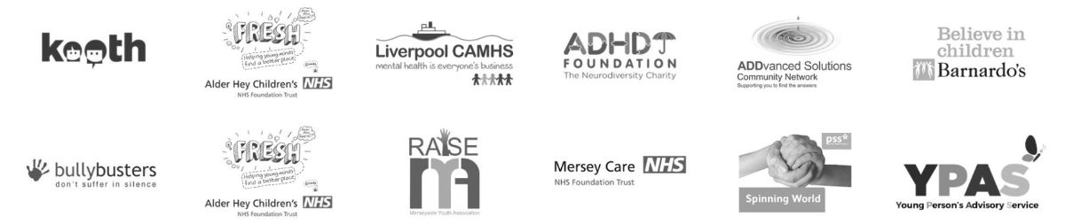



Copyright © 2020 Merseyside Youth Association, All rights reserved.
You are receiving this email because you opted in to hear about Liverpool CAMHS news and events.
Our mailing address is:
Merseyside Youth Association
Merseyside Youth Association
65-67 Hanover Street
Liverpool, Merseyside L1 3DY
United Kingdom
Add us to your address book
Want to change how you receive these emails?
You can update your preferences or unsubscribe from this list

