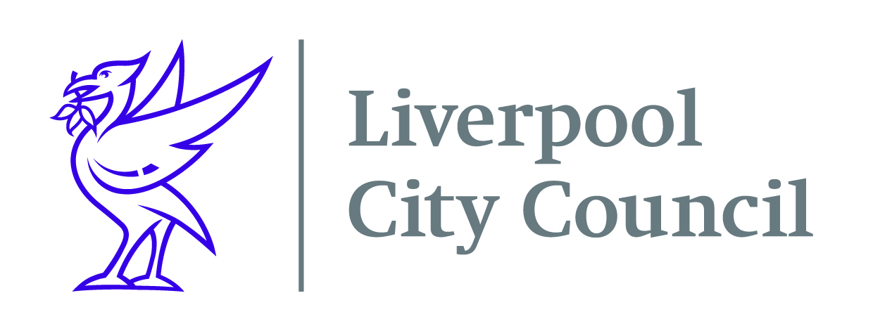

Date: 11th October 2021

Dear Parent or Guardian
The #OPAL holiday activity programme is a packed half term programme bursting with great activities and delicious meals every day.
Children and young people will be able to access hundreds of activities throughout the half term holidays, including specific provision available for children with SEND or additional needs, at no cost to you. Many of the activity providers are holding Halloween themed week of activities as well as boxing, trampolining, football, pony riding, music, dance, circus skills, cycling, cooking, climbing, films, gardening, arts and crafts, forest school, photography, trips out, yoga, djing, ice skating and many other exciting opportunities.
To find out where your nearest scheme is please click on this link - October Half Term Play and Activities (OPAL) – Merseyside Play Action Council or visit www.Merseyplay.com and click on the OPAL link.
When you have chosen an activity, you will need to contact that organisation to book a place. If your child has any additional needs or dietary requirements then please discuss this with the organisation when you book.
Liverpool City Council is working with local schools, voluntary and community organisations, and childcare providers to provide the OPAL programme.
Included with this email is information regarding additional support available for residents who may have been affected by recent events such as changes to benefits, energy price increases, furlough ending or for anyone struggling to make ends meet.
Regards
Sally Dobbing
Sally Dobbing - HAF Project Manager

