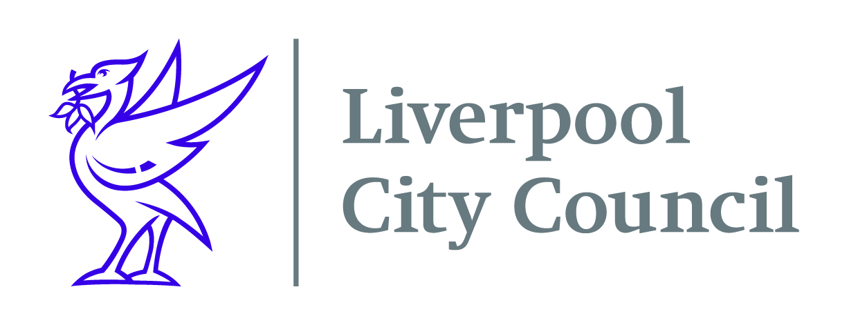

Date: 30th June 2021

Dear Parent or Guardian
#ASummerToRemember holiday activity programme is a packed summer programme bursting with great activities and delicious meals every day!
This opportunity is provided as part of the government’s expanded Holiday Activities and Food (HAF) programme being delivered across Liverpool which also covers the Christmas holidays in 2021.
The scheme provides enjoyable activities and nutritious meals for primary and secondary school aged children.
Children will be able to access hundreds of activities throughout the summer holidays, including specific provisions available for children with SEND or additional needs, at no cost to you. The sessions will include a variety of fun activities, including sports, music, arts and other exciting opportunities to learn and develop skills.
To find out where your nearest scheme is please visit www.merseyplay.com . Information on contact details for local progammes in your area will be available from 8th July.
If you have any queries regarding the HAF programme, please call MPAC on 0151 708 0468 or email info@merseyplay.com. In addition to this programme, families who are eligible for Universal Credit may be able to claim back up to 85% of their childcare costs. Please visit https://www.gov.uk/help-with-childcare-costs to find out more.
Liverpool City Council is working with local schools, voluntary and community organisations, and childcare providers to provide the HAF programme. The free places are funded by the Department for Education.
We look forward to creating #ASummerToRemember for your child!
Regards
Sally Dobbing
HAF Project Manager

