**Infant Safer Sleep Twittter Pack- Message of the day**

This is **#safersleep** week please help spread the word about safe infant sleep. Please use the following hashtags and localise for your ICB/ Place.

**#SaferSleep #SaferSleepWeek #SaferSleepGM #SaferSleepC&M #SaferSleepL&SC**

**#SaferSleep** (add your Place here)

**Monday**

Always follow the ABC’s of safe sleep

[Safer sleep for babies (text free) - YouTube](https://www.youtube.com/watch?v=RZA7_qpF2H0)

**Tuesday**

**#safersleep** week During the cold winter months families may also be worried about keeping their baby warm enough, but it’s important that babies are a comfortable temperature-not too hot or too cold • A room temperature of 16-20 degrees C is advised

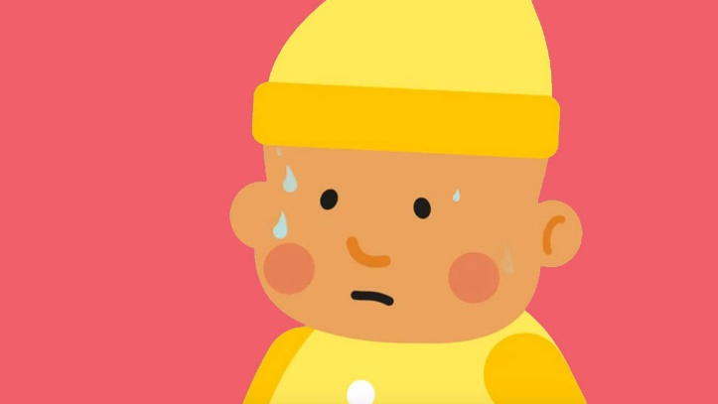

[What bedding does my baby need? - YouTube](https://www.youtube.com/watch?v=cM2RX2SAV4M)

**Wednesday**

**#safersleep** week Visiting over the holidays ? Think ! Where is your baby going to sleep? Car seats keep babies safe while travelling, they are not a sleeping place. Young babies are at risk of breathing difficulties if upright in car seats for a long period of time.

<https://assets.publishing.service.gov.uk/government/uploads/system/uploads/attachment_data/file/901091/DfE_Death_in_infancy_review.pdf>

**Thursday**

**#safersleep** week Being a new dad is an amazing experience But it’s also exhausting. It’s something no-one can prepare you for. And at the end of a long day, there’s nothing more satisfying than to collapse on the sofa. And that’s where we need to stop you! More than 130 babies die in the UK every year as a result of unsafe sleeping.

[LiftTheBaby.org.uk - YouTube](https://www.youtube.com/watch?v=vtdLc6MtOxo&t=13s)

**Friday**

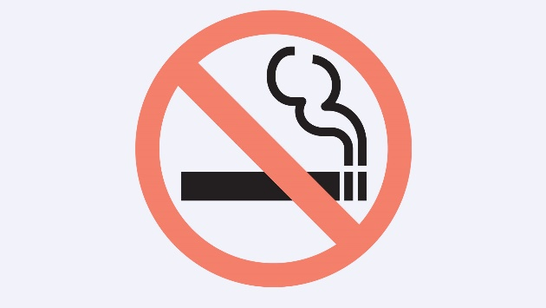

**#safersleep** week Smoking cigarettes during pregnancy or after birth can significantly increase the risk to your baby . Around 30% of sudden infant deaths could be avoided if mothers didn’t smoke when they were pregnant. Taken together with the risks of smoking around a baby at home, this means that smoking could be linked to 60% of sudden infant deaths.

[Smoking during pregnancy or after birth increases the risk of SIDS - The Lullaby Trust](https://www.lullabytrust.org.uk/safer-sleep-advice/smoking/)