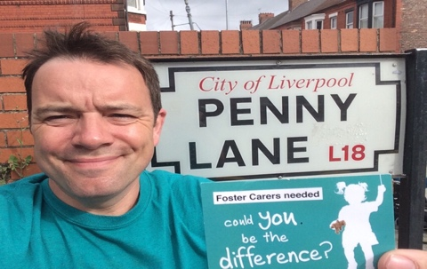

Liverpool has over 1600 Looked After Children. Could you foster one?

Phil Watson and his family started fostering for Liverpool City Council in 2010.

‘It can be challenging, exhausting, hilarious, but above all rewarding. I can see the difference we are making to the children we have looked after. We have fostered seven kids since we started. We had one little lad for four hours and one kid for over eight years! We can’t solve all their problems, but we know when those kids are with us, they are safe.’

Foster carers need to be over 21, be in reasonably good health and have a spare room. You can be of any background, creed, culture, heritage or sexual orientation. You can be single, in a relationship, own your home or rent. You don’t need to give up work to foster, as long as your work is flexible enough to cope with the demands of looking after a child.

As well as being paid, foster carers are exempt from Council Tax and get free Lifestyles Gym Membership. Full training and support is given. Liverpool City Council are actively looking to find new carers.

If you are interested in finding out more about fostering for Liverpool, contact Phil Watson at [Phil.Watson@liverpool.gov.uk](mailto:Phil.Watson@liverpool.gov.uk) or visit [www.fostering.liverpool.gov.uk](http://www.fostering.liverpool.gov.uk)