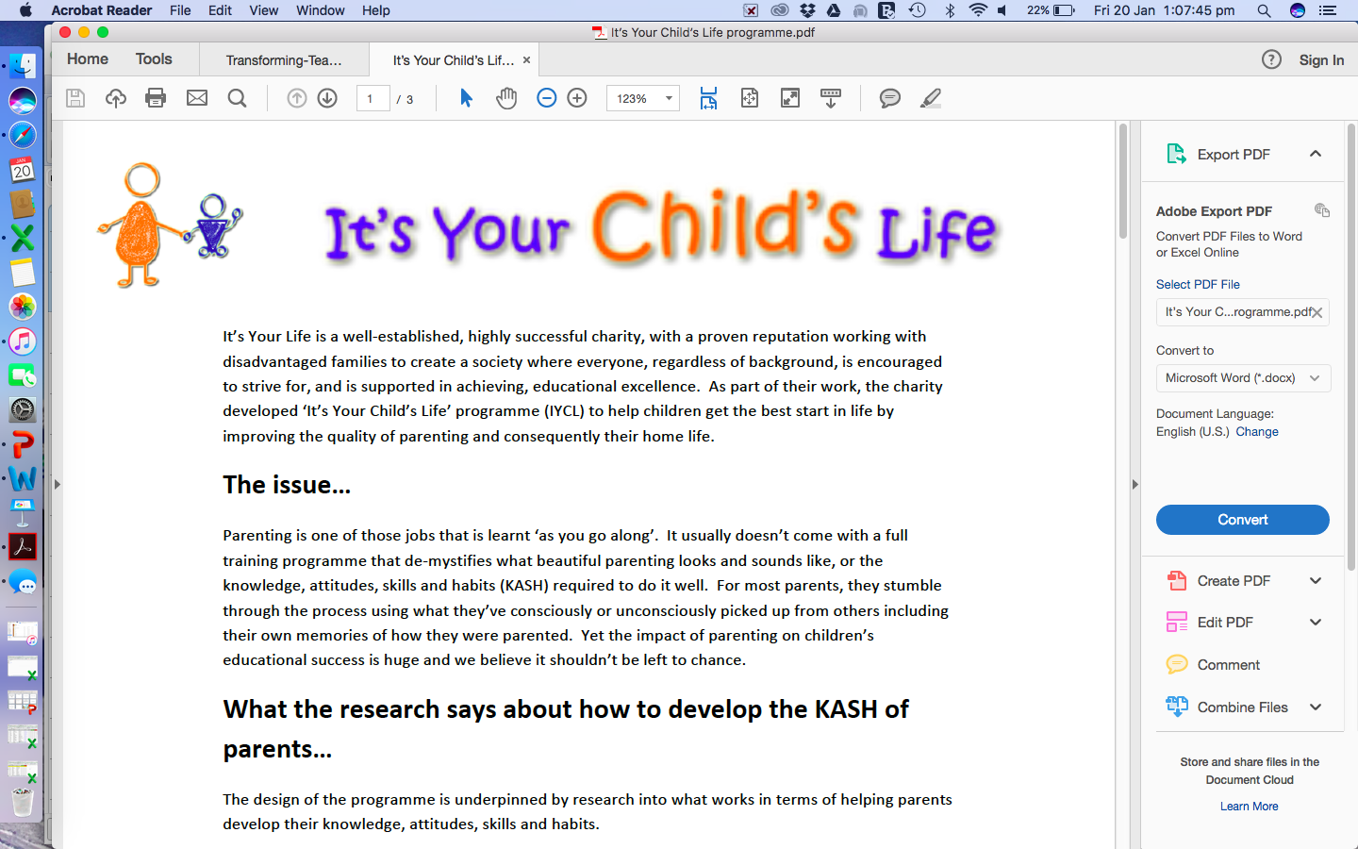

Dear Parent/Carer,

The ‘It’s Your Child’s life’ course is coming to Our Lady and St Philomena’s Catholic Primary School on Monday 9th January to help you help your child thrive at school. This 6 week course runs for an hour in school just before you pick up your child at the end of the school day. We’ll have the kettle on at 2pm!

The course gives you a real insight into what your child will be learning at school and how they are being taught. Each week you’ll receive lots of practical tips and ideas as to how to help your child develop skills in reading, writing, maths, confidence and resilience. You will be given a booklet full of resources and ideas for fun games to play with your child at home which helps them embed what they have learnt in school. The course is also a good chance to meet other parents and share ideas and experiences with them. Parents who have done the course say they have noticed a big difference in their child.

The course is open to all parents/grandparents/carers of Reception. However, places are limited at this time to 10 parents so be quick to respond! Don’t worry if you can’t make all 6 sessions as a grandparent could stand in for you if needed.

Please click on the link below to find out more about the course and read our testimonials from teachers and parents alike.

<https://www.itsyourlife.me.uk/liverpool>

If you’d like to sign up for the course, please fill in the details below and hand your form in to your child’s teacher. We look forward to seeing you!

Name……………………………………………………………………………..

Child’s name…………………………………………………………………

What parents have said about the course……..

“My child’s confidence and handwriting has come on leaps and bounds”

“I had no confidence helping my child with maths. Now I know lots of ways to make maths fun for my son “

“I finally understand how to support my child with phonics”