  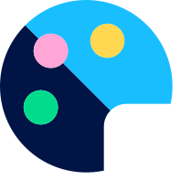  Art and design  Vocabulary progression  Standard | 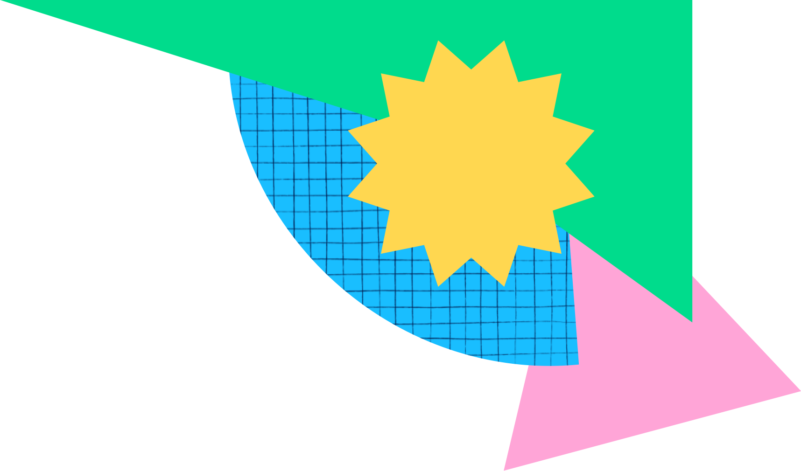
This version was updated on 01/10/2026, 10:20
Copyright: While we encourage you to share this document within your school community, please ensure that it is only uploaded to your school website if it is password protected.

Overview - Vocabulary progression
Overview - Vocabulary progression
Unit 1
Year 1 | Year 2 | Year 3 | Year 4 | Year 5 | Year 6
abstract  artist  circle  collage  control  curved  dotted  dashed  feature  line  organic  portrait  pressure  rectangle  side  shape  sketch  straight  square  triangle  wavy  zigzag | artist  chalk  charcoal  crayon  control  detail  evaluate  graphite stick  grip  line  mark making  materials  organic  outline  pastel  pressure  refine  rubbing  shading  shadow  shape  sketch  subject  texture  tone | artist  blend  digital art  even tones  geometric  grip  illustrator  inspiration  line  mark making  materials  observation  observational drawing  organic  pattern  pressure  product  purpose  refine  sketch  shading  shape  style  tone | balanced  ballpoint pen  collage  composition  cross hatching  exaggerated  focal point  form  highlight  layer  observation  observational drawing  organic  pattern  proportion  realistic  refine  shading  shadow  sketch  texture  three-dimensional  tone  unbalanced | abstract  background  balanced  composition  depth  emotion  emphasise  expressive  focal point  foreground  form  main subject  middle ground  observation  portrait  print  printmaking  printing plate  process  proportion  realistic  refine  shading  tone | depth  graffiti  graffiti tag  horizon  mural  one point perspective  proportion  realism  scale  street art  vanishing point
*Words on this page are classified as Tier 2 words unless stated otherwise.
Overview - Vocabulary progression
Unit 1
Year 1 | Year 2 | Year 3 | Year 4 | Year 5 | Year 6
abstract  artist  circle  collage  control  curved  dotted  dashed  feature  line  organic  portrait  pressure  rectangle  side  shape  sketch  straight  square  triangle  wavy  zigzag | artist  chalk  charcoal  crayon  control  detail  evaluate  graphite stick  grip  line  mark making  materials  organic  outline  pastel  pressure  refine  rubbing  shading  shadow  shape  sketch  subject  texture  tone | artist  blend  digital art  even tones  geometric  grip  illustrator  inspiration  line  mark making  materials  observation  observational drawing  organic  pattern  pressure  product  purpose  refine  sketch  shading  shape  style  tone | balanced  ballpoint pen  collage  composition  cross hatching  exaggerated  focal point  form  highlight  layer  observation  observational drawing  organic  pattern  proportion  realistic  refine  shading  shadow  sketch  texture  three-dimensional  tone  unbalanced | abstract  background  balanced  composition  depth  emotion  emphasise  expressive  focal point  foreground  form  main subject  middle ground  observation  portrait  print  printmaking  printing plate  process  proportion  realistic  refine  shading  tone | depth  graffiti  graffiti tag  horizon  mural  one point perspective  proportion  realism  scale  street art  vanishing point
*Words on this page are classified as Tier 2 words unless stated otherwise.

